How to Improve the Accuracy of the Random Forest Method

We altered the algorithm for the Random Forest to try and improve the method so the result became more accurate, however, we were unable to use python, so we below there is a demonstration that shows how we would improve the algorithm.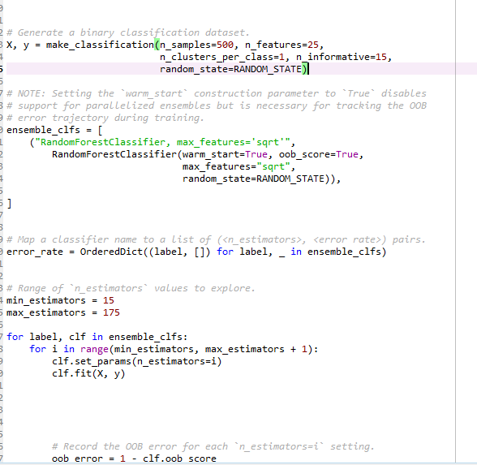

Accuracy of the system refers to how often the classifier will generate the correct result when running through a set of data. The accuracy of the ensemble can be improved through increasing the number of classifiers. However, this method will only hold true if all classifiers exhibit an accuracy of greater than or equal to five. Thus from this statement, it can be further concluded that the accuracy of the system can be improved by removing classifiers that have an accuracy of below 0.5. Also as seen above, we would have increased the sample size to 500 in an attempt to remove the amount of errors, which is represented by the graph below/other page.

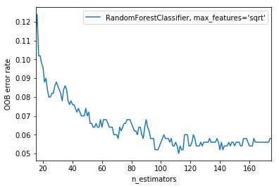  
Figure 1: Sample size against error rate/amount of area.

As you can see from the graph, as the sample size increases, the error rate/amount of errors found significantly decreases, proving that our alteration would have made the Random Forest algorithm more accurate as there are less errors.